ECEN 4/5632 Theory and Application of Digital Filters Fall 2026
10-2-26 P. Mathys

Problem Set 6: Solution
1. Conv1d and the sliding dot product
Given the DSP convolution sum $y_{DSP}\left[n\right]=\sum_{k}{h\left[k\right]x[n-k]}$ and PyTorch’s cross-correlation convention $y_{torch}\left[n\right]=\sum_{k}{w\left[k\right]x[n+k]}$:
(a) Derive the relationship $w\left[k\right]=h[M-k]$ (where $h$ has $M+1$ taps, indices $0,…,M$) that makes F.conv1d reproduce the textbook causal FIR convolution, and state the required left-padding amount.

(b) Implement both, the NumPy convolution np.convolve and the equivalent F.conv1d computation for a Hamming-windowed FIR lowpass filter with $ω_{c}=π/3$ and length $N=51$ on a chirp signal (chirp_001.wav). Report the maximum absolute difference between the two outputs (you should get something on the order of ${10}^{-6}$ to ${10}^{-7}$ in float32). Show evidence that your filter works as desired (e.g., by recording the filtered chirp signal as .wav-file and using a program like Audacity to generate a spectrogram). Show all your Python and PyTorch code in your solution.
Python code, part 1
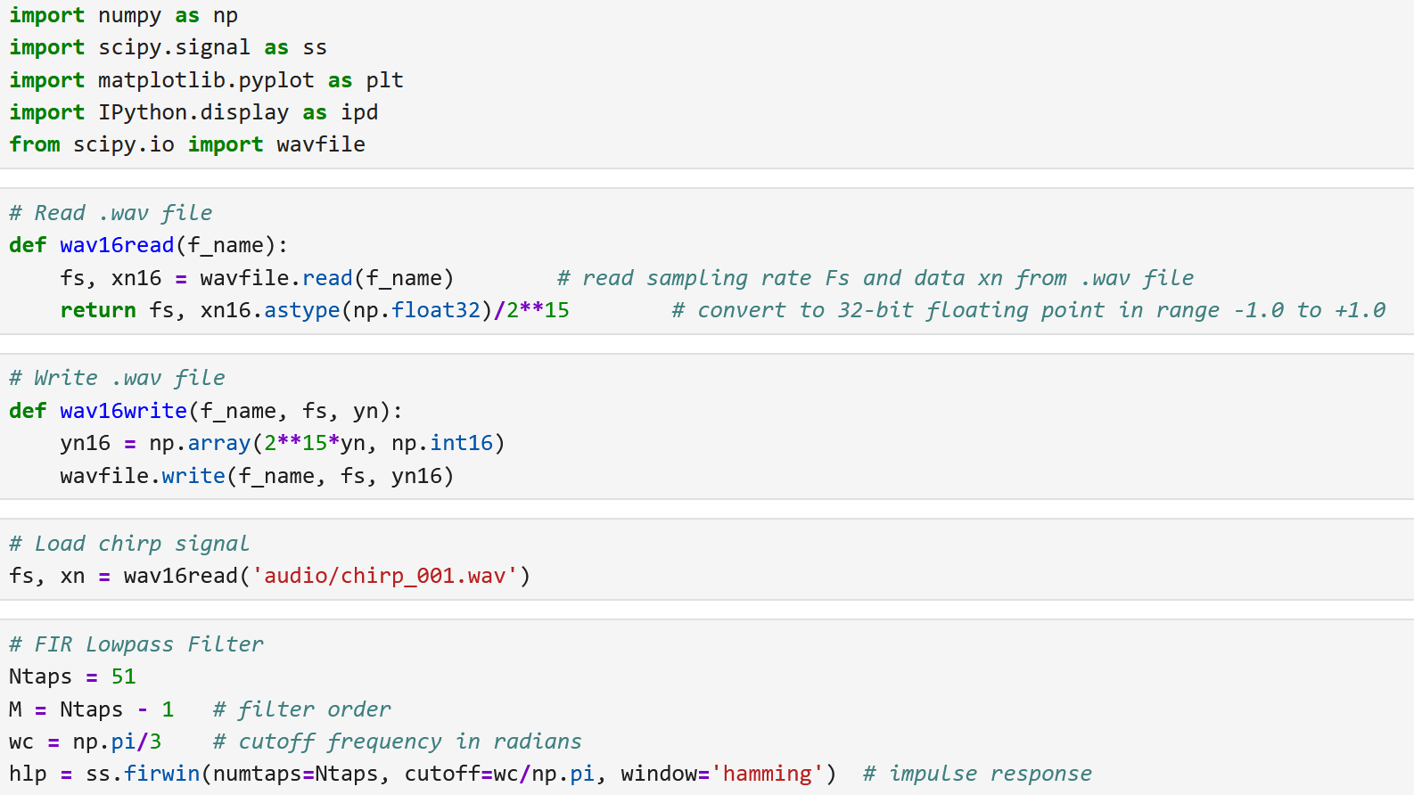
Lowpass filter, time and frequency domain response
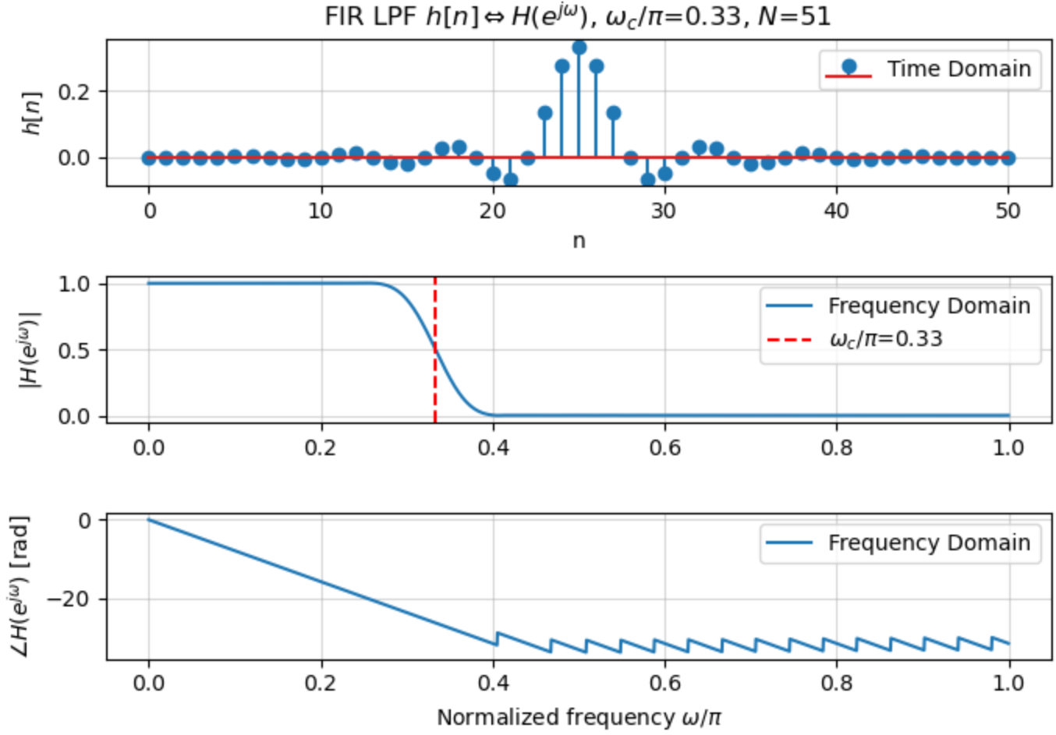

Python code, part 2
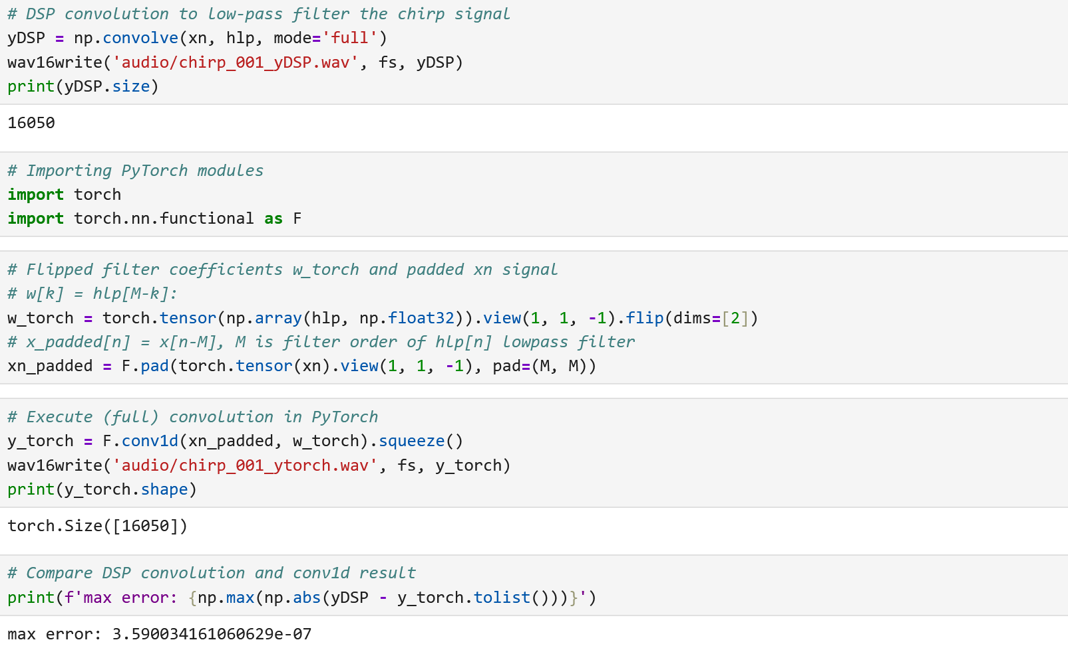
Note that the maximum error between the numpy.convolve() and the torch.nn.functional.conv1d() is only about $3.59×{10}^{-7}$.
Time waveforms and spectrograms from Audacity, original Chirp signal:
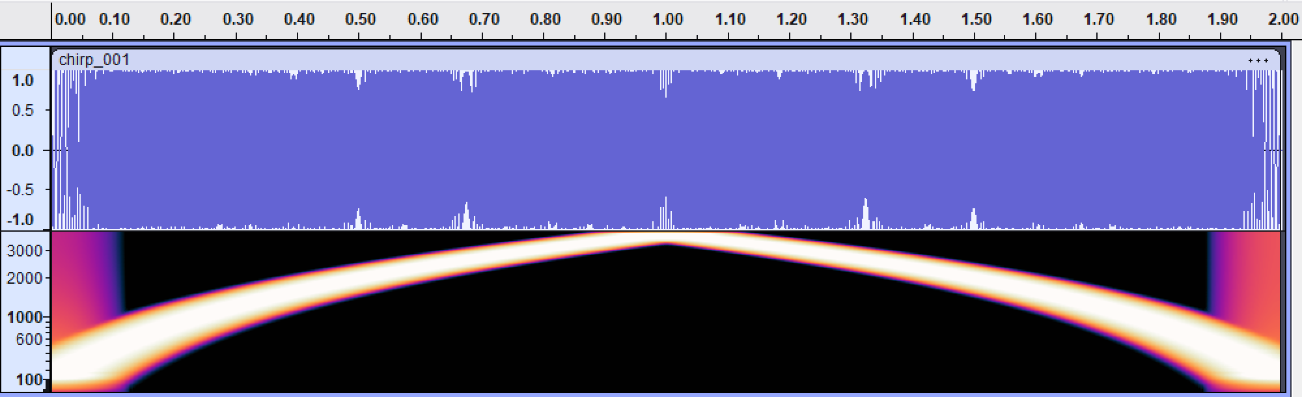

After DSP low-pass filtering:
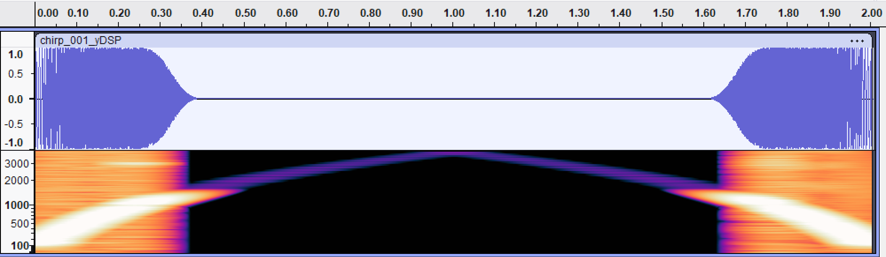
After conv1d low-pass filtering:
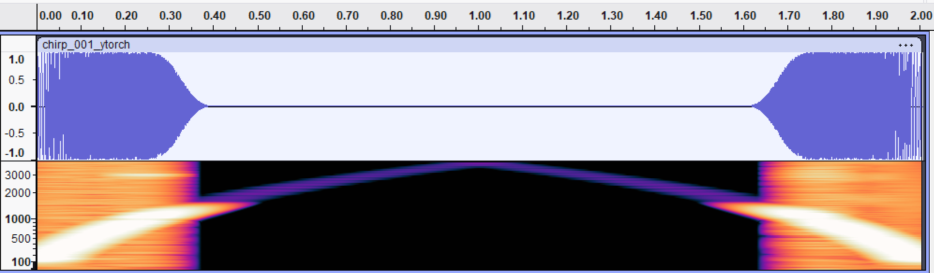

(c) A colleague says “PyTorch’s conv1d does convolution backwards, so it’s a bug.” Give a one-paragraph rebuttal, using the ML viewpoint discussed in lecture.
Rebuttal: It's not a bug, just a different (and for machine learning purposes, more natural) convention. Mathematically, convolution and cross-correlation differ only by flipping the kernel, $w[k] = h[M-k]$, exactly as derived in part (a), so no information or capability is lost, and the two are trivially interconvertible. In classical DSP the kernel $h[k]$ is a fixed, physically meaningful impulse response, derived from a difference equation or an analog prototype, so the flip in the definition matters and must be tracked carefully. In deep learning, however, the kernel $w[k]$ is a set of learned parameters with no prior physical meaning: gradient descent will happily learn whichever set of numbers minimizes the loss, whether the operation is called “convolution” or “correlation.” Since training and inference both consistently use the same cross-correlation definition, and autograd computes the correct corresponding gradients automatically, there is no mismatch anywhere in the pipeline. The “backwards” framing only becomes an issue when reusing a fixed, externally designed filter, like the FIR filter in part (b), inside a conv1d call, and even then, as shown above, it is a one-line fix: flip the kernel and left/right-pad by $M$, not a bug.

2. Pole-zero geometry
For
$$H\left(z\right)=\frac{1-0.8z^{-1}}{1+0.5z^{-1}}$$
(a) Identify the zero and the pole.
(b) Explain geometrically why $\left|H(e^{jω}\right)|$ is the product of zero-vector lengths divided by the product of pole-vector lengths.
(c) Predict qualitatively whether the magnitude is larger near $ω=0$ or $ω=π$.

3. Phase delay and group delay
Let $H\left(e^{jω}\right)=\left|H\left(e^{jω}\right)\right|e^{jϕ(ω)}$ with $ϕ\left(ω\right)=-3ω+0.4sin⁡(ω)$.
(a) Compute the phase delay
$$τ_{p}\left(ω\right)=-\frac{ϕ(ω)}{ω}$$
for $ω≠0$.
(b) Compute the group delay
$$τ_{g}\left(ω\right)=-\frac{dϕ\left(ω\right)}{dω}.$$
(c) Explain why the system is not linear phase.

4. First order allpass
For real $\left|a\right|<1$,
$$H_{ap}\left(z\right)=\frac{z^{-1}-a}{1-az^{-1}}.$$
Show that
$${|H}_{ap}\left(e^{jω}\right)|=1$$
for all $ω$. Locate the pole and zero and explain the reciprocal relationship.

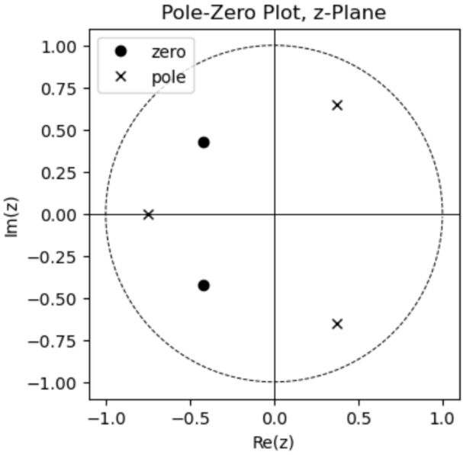
5. Inverse system properties (ECEN 5632 Problem)
If the system function $H(z)$ of an LTI system has a pole-zero plot as shown on the right and the system is causal, can the inverse system $H_{i}(z)$, where $H\left(z\right)H_{i}\left(z\right)=1$, be both causal and stable? Clearly justify your answer.

